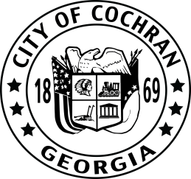
AGENDA
Cochran City Council
Tuesday, March 12, 2024
Work Session @ 6:00PM

City Auditorium, 102 N Second Street, Cochran, GA 31014
____________________________________________________________________________

City Council | City Staff
Billy Yeomans, Mayor  Lonnie Tedders  (District 2, Post 2) | Richard Newbern, City Manager  Tracy Jones, City Clerk
Carla Coley, Council Member  (District 2 Post 1) | Jim Elliott, City Attorney
Gary Ates, Council Member
(District 1, Post 2)
Shane Savant
(District 3, Post 2)
Andrew Lemmon, Council Member
(District 3, Post 1)
Keith Anderson, Council Member
(District 1, Post 1)

- Call to Order by the Mayor
- Invocation
III. Pledge of Allegiance
- Attendance
- Adopt Agenda/Minutes

VI. Agenda Items

ITEM #1- Presented by City Manager, Richard Newbern
Update on Budget preparation

ITEM #2- Presented by City Manager, Richard Newbern
Report on Park Committee recommendations

ITEM #3- Presented by City Manager, Richard Newbern
Discussion of proposed Resolution concerning Council Open Records Requests

ITEM #3- Presented by City Manager, Richard Newbern
Department Head reports

VII. City Manager Discussion/Items/Updates
VIII. Council Discussion Items

IX. Announcement of Upcoming Meetings and Events

- Regularly Scheduled City Council Work Session – Tuesday, April 9, 2024 @ 6:00 pm
- Regularly Scheduled City Council Meeting – Tuesday, April 9, 2024 @ 7:00 pm

